HTML5 Developer Assignment
Instructions:
Using JavaScript develop a card game based on the following requirements. The game is a simplified version of Texas Hold’em. The following are provided:
- Card Spritesheet
- 4 sets of data containing player cards (the pocket), the flop, the turn and the river.
Format the provided data accordingly to be used as an external resource in the game. Use format of your choosing.
The basic game flow consists of dealing pocket cards to player. Upon checking, the flop, river and turn will be revealed. At the end of the hand, a hand analysis needs to be conducted to indicate the highest hand rank the player achieved. Create an algorithm to determine ALL possible hands that the player could have. A display panel needs to be shown to the player at this point.
Step 1:
- The game starts with a deal button.
Step 2:
- The deal button is clicked and The Pocket is shown to the player. There does not need to be any animations. The deal button becomes a ‘check’ button (since there is no actual betting).
Step 3:
- The check button is clicked and The Flop is shown above the players Pocket cards.
Step 4:
- The check button is clicked again and The Turn is shown to the right of the Flop cards.
Step 5:
- The check button is clicked a final time and The River is shown to the right of the Turn card. ‘Check’ button changes to ‘Re-deal’
Step 6:
- The final 7 cards are evaluated to their best hand. Display the results using a CSS styled panel.
Step 7:
- Clicking ‘Re-deal’ cleans up the previous hand, and starts game play again at step 1.

Provided Hand Data:
The first four hands must be dealt using the provided data below. All subsequent hands should be randomly drawn using one deck of 52 cards without jokers.
Hand 1:
Pocket: 10 of spades, Jack of spades
Flop: 7 of hearts, 2 of diamonds, Queen of spades
Turn: King of spades
River: Ace of spades
Hand 2:
Pocket: 10 of spades, Jack of spades
Flop: King of spades, 2 of diamonds, Queen of spades
Turn: 9 of spades
River: 7 of hearts
Hand 3:
Pocket: Ace of hearts, 7 of diamonds
Flop: Ace of spades, Ace of diamonds, 7 of spades
Turn: Ace of clubs
River: 7 of hearts
Hand 4:
Pocket: King of hearts, 7 of diamonds
Flop: Ace of spades, Ace of diamonds, 7 of spades
Turn: King of clubs
River: 7 of hearts

Poker Rankings:
Poker rankings for any hand containing 5 cards are defined in the following order - from highest to lowest (examples shown):

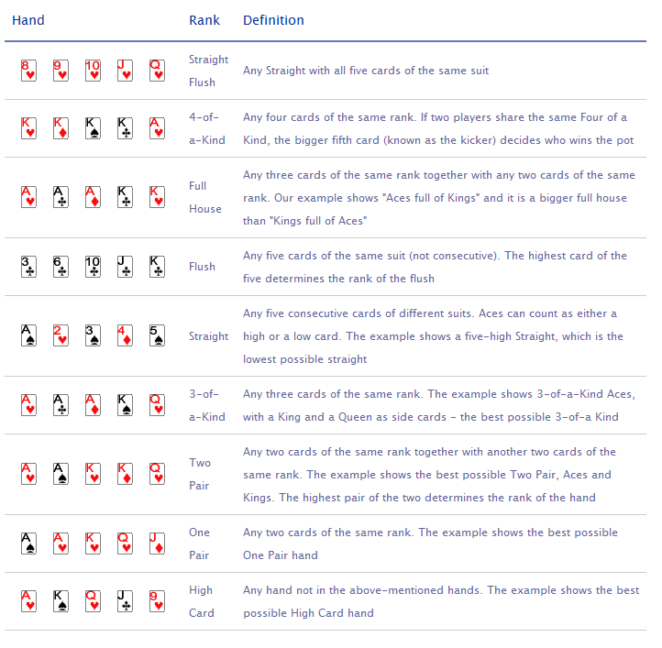
Deliverables:
- Please provide all source code and brief descriptions of the application.
- Please provide a fully debugged application with all necessary resources which must run on major web browsers.
Additional Notes:
- We are looking at application architecture and organization.
- Display hand results and analysis using CSS styling
- There will be bonus points for animations, but they are not necessary
- Do not use external poker related references and resources for designing the hand analysis algorithm and/or writing the actual program.
- There is no need to have the absolute best performance, just a reasonable balance between complexity and performance

